

COMP 8347

Internet Applications and Distributed Systems

Lab 5

Submitted to: Dr. Adel Abusitta

June 12, 2023

*Submitted By:*

*Hamza Baig (110089314)*

*Harsimran Singh (110090200)*

*Vivek Verma (110094354)*

*Talha Muhammad Shamoon Chaudhry (110087321)*

*Vidya Sehgal (110090510)*

*Komalben Kishorbhai Patel (110091595)*

*Abhishek Singh (110089745)*

Part 1

1. Below screenshot displays changed views.py file.

1. Below screenshot shows changed urls.py file

c.)

1. Started server and 127.0.0.1:8000 show the all car details.

1. We can use [:10] to get only 10 listings and order by function to sort the listings.

1. Below screenshots shows the details of getting car details.

Below screenshots shows the details of all the cars with type 1.

1. If no type is present user will see the message that No Vehicle matches display 404 error page.

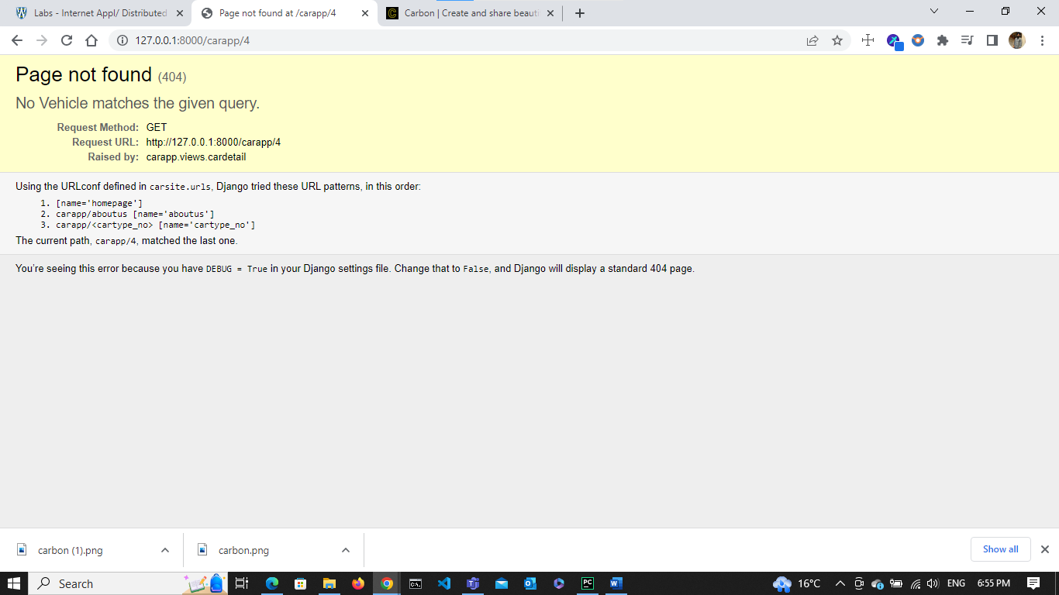

Part 2

1. Model.py showing Group member fields.

1. View.py

1. Template for displaying lab members.

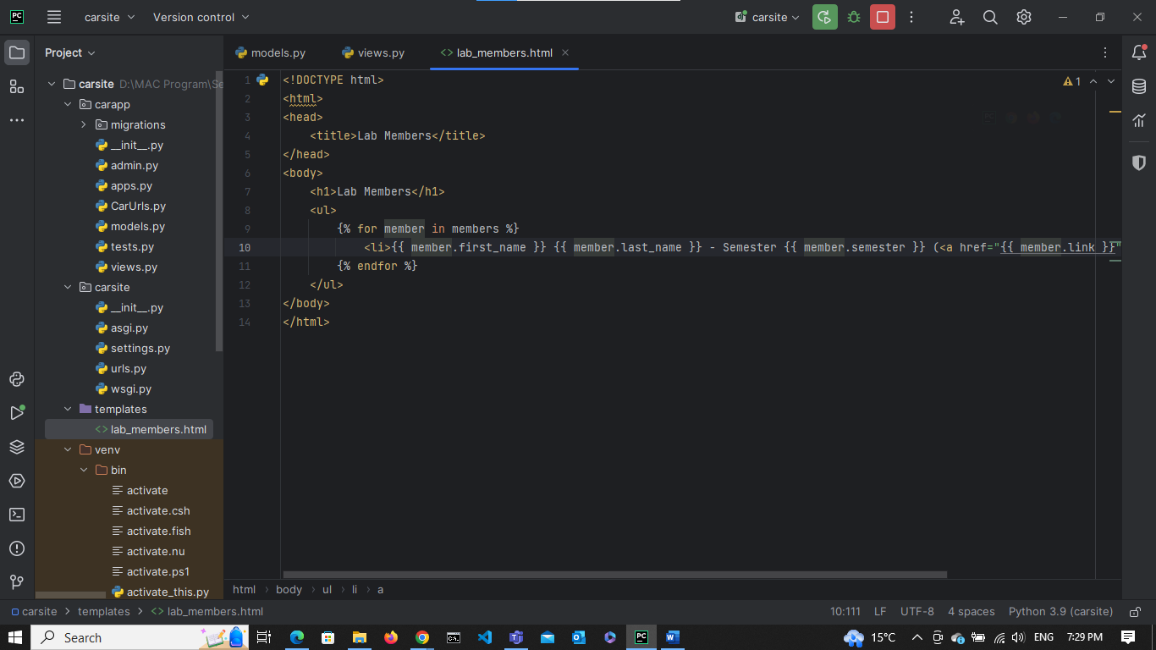

1. Screenshot below displays when running <http://127.0.0.1:8000/members/> displays all the lab members details sorted according first name.

Part 3

**FBV:**

**CBV:**

**Changes to URLs:**

**Differences Noticed:**

# Differences between FBV and CBV  
# 1. The syntax for both views is different, as one is function based and the other uses class definitions.  
# 2. CBVs inherit from the View class and the FBVs don't have a base class  
# 3. CBVs have methods such as get() and post(), we have only used get() in this lab.  
# 4. Code organization is much better in classes, so CBVs have a much organized code, which doesn't seem like a big  
# problem for this lab as the code isn't that long but as the code base increases in size, CBVs will prove to be easily  
# readable.